PROGRAM 6: DEPTH FIRST SEARCH (DFS)

Aim
To write a Python program to implement Depth First Search (DFS) traversal of a graph.

Objective
To traverse all the vertices of a graph using the Depth First Search (DFS) algorithm.

Algorithm
- Start.
- Create a graph using an adjacency list.
- Mark all vertices as unvisited.
- Visit the starting vertex and print it.
- Mark the vertex as visited.
- Recursively visit all unvisited adjacent vertices.
- Repeat until all vertices are visited.
- Stop.

Source Code
graph = {
'A': ['B', 'C'],
'B': ['D', 'E'],
'C': ['F'],
'D': [],
'E': [],
'F': []
}

visited = []

def dfs(node):
if node not in visited:
print(node, end=" ")
visited.append(node)

for i in graph[node]:
dfs(i)

dfs('A')
Flowchart
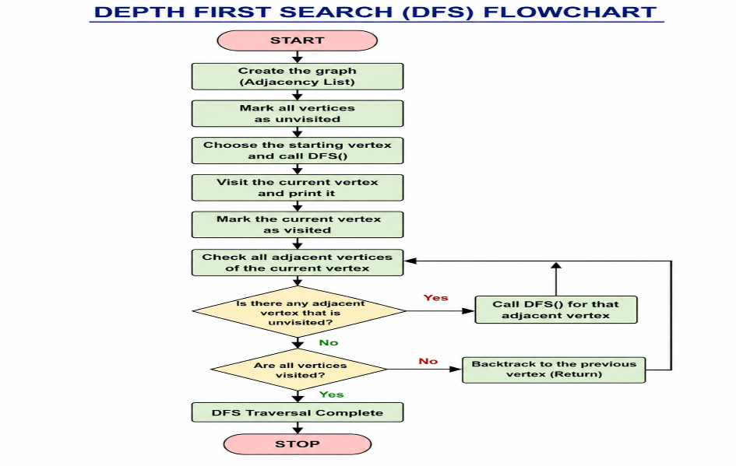

Sample Output
A B D E C F
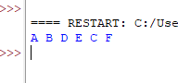
Result
Thus, the Python program to implement Depth First Search (DFS) was executed successfully.

